**Windows PC - Installing Influx v1**

https://portal.influxdata.com/downloads/

Scroll down to

**Are you interested in InfluxDB 1.x Open Source?**

Drop down V arrow and select

InfluxDB v1.8.10

Platform: Windows Binaries (64 Bit) - using PowerShell

Start Windows PowerShell in Administrator mode

Copy the wget installation instructions and paste to PowerShell

Installation will begin. Hit enter to expance zip file to C:\Program Files\InfluxData\influxdb\influxdb-1.8.10-1

To Start Influx Server Navigate to : C:\Program Files\InfluxData\influxdb\influxdb-1.8.10-1

> .\influxd to start the daemon / service

then

>.\influx to enter influxdb shell



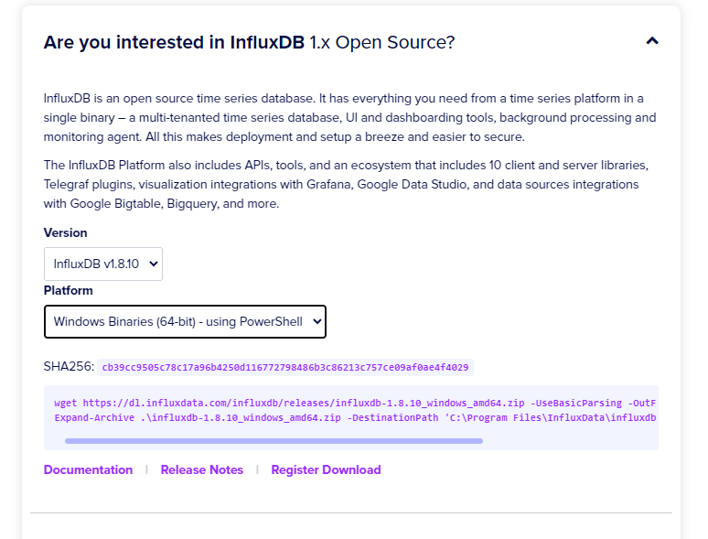

If for some reason you cannot get this to download (in my case it was something to do with SSL, then download the zip file manually)

Do it from your browser.

**https://dl.influxdata.com/influxdb/releases/influxdb-1.8.10_windows_amd64.zip**

the zip file will go to your downloads folder. Unzip the file and copy the folder to

**C:\Program Files\influxdb-1.8.10-1**

You will see the following in this folder

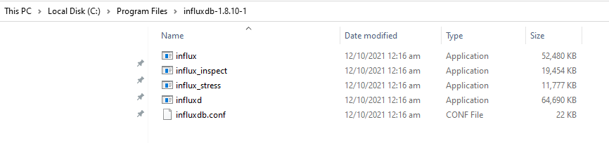

Start up a Command Terminal in Administrator mode

Navigate to **C:\Program Files\influxdb-1.8.10-1**

Run influxd

**Influxd is the daemon / service for Influxdb**

Start up another Command Terminal in Administrator mode

Navigate to **C:\Program Files\influxdb-1.8.10-1**

Run influx

Influx is the shell from which you manage your databases